Lab Taks-2

Submission Guidelines-
- Rename the file to your id only. If your id is 18-XXXXX-1, then the file name must be 18-XXXXX-1.docx.
- Must submit within time that will be discussed in class VUES to the section named Lab Tak-2
- Must include resources for all the section in the table
Question- 1

Draw a Rainbow Flag

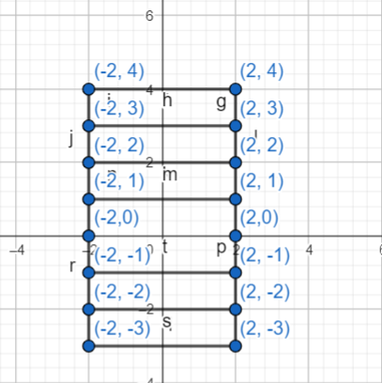
Graph Plot (Picture)-

Code-
#include <windows.h> // for MS Windows
#include <GL/glut.h> // GLUT, include glu.h and gl.h
void code()
{
glPointSize(5.0);
glBegin(GL_POLYGON);
glColor3f(1.0f, 0.0f, 0.0f); // Red
glVertex2f(-3.0f, -3.0f);
glVertex2f(3.0f, -3.0f);
glVertex2f(3.0f, -2.0f);
glVertex2f(-3.0f, -2.0f);
glEnd();
glFlush();
glPointSize(5.0);
glBegin(GL_POLYGON);
glColor3f(1.0f, 1.0f, 0.0f); // Yellow
glVertex2f(-3.0f, -2.0f);
glVertex2f(3.0f, -2.0f);
glVertex2f(3.0f, -1.0f);
glVertex2f(-3.0f, -1.0f);
glEnd();
glFlush();
glPointSize(5.0);
glBegin(GL_POLYGON);
glColor3f(1.0f, 0.5f, 0.0f); //Orange
glVertex2f(-3.0f, -1.0f);
glVertex2f(3.0f, -1.0f);
glVertex2f(3.0f, 0.0f);
glVertex2f(-3.0f, 0.0f);
glEnd();
glFlush();

glPointSize(5.0);
glBegin(GL_POLYGON);
glColor3f(0.0f, 0.70f, 0.0f); // Green
glVertex2f(-3.0f, 0.0f);
glVertex2f(3.0f, 0.0f);
glVertex2f(3.0f, 1.0f);
glVertex2f(-3.0f, 1.0f);
glEnd();
glFlush();

glPointSize(5.0);
glBegin(GL_POLYGON);
glColor3f(0.0f, 0.70f, 0.68f); // Blue
glVertex2f(-3.0f, 1.0f);
glVertex2f(3.0f, 1.0f);
glVertex2f(3.0f, 2.0f);
glVertex2f(-3.0f, 2.0f);
glEnd();
glFlush();

glPointSize(5.0);
glBegin(GL_POLYGON);
glColor3f(0.50f, 0.0f, 1.0f);
glVertex2f(-3.0f, 2.0f);
glVertex2f(3.0f, 2.0f);
glVertex2f(3.0f, 3.0f);
glVertex2f(-3.0f,3.0f);
glEnd();
glFlush();
glPointSize(5.0);
glBegin(GL_POLYGON);
glColor3f(0.40f, 0.0f, 0.50f);
glVertex2f(-3.0f, 3.0f);
glVertex2f(3.0f, 3.0f);
glVertex2f(3.0f, 4.0f);
glVertex2f(-3.0f,4.0f);
glEnd();
glFlush();
}
void display() {
glClearColor(0.0f, 0.0f, 0.0f, 1.0f); // Set background color to black and opaque
glClear(GL_COLOR_BUFFER_BIT); // Clear the color buffer (background)

code();
glEnd();

glFlush(); // Render now
}
int main(int argc, char** argv) {
glutInit(&argc, argv);
glutInitWindowSize(500,500);
glutInitWindowPosition(10,10);
glutCreateWindow("LAB TASK2"); // Create a window with the given title

glutDisplayFunc(display); // Register display callback handler for window re-paint
gluOrtho2D(-8,8,-8,9);
glutMainLoop(); // Enter the event-processing loop
return 0;
}

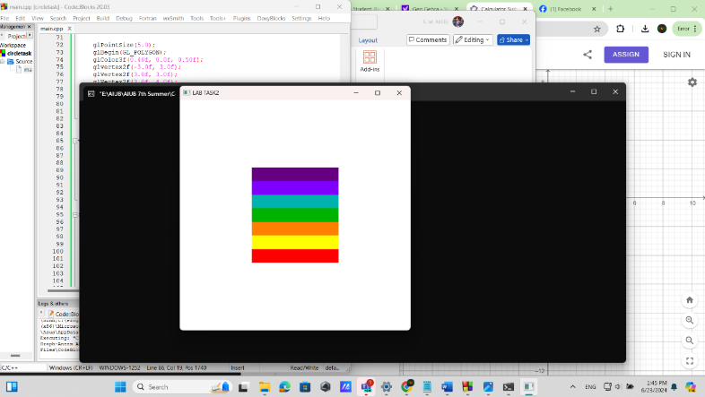
Output Screenshot (Full Screen)-

Question- 2

Draw 4X4 Chess Board

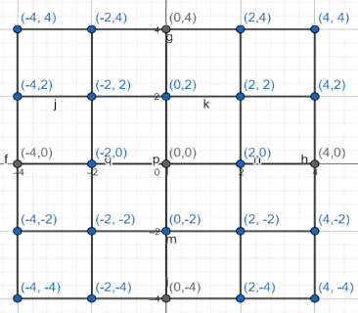
Graph Plot (Picture)-

Code-
#include <windows.h> // for MS Windows
#include <GL/glut.h> // GLUT, include glu.h and gl.h

/* Initialize OpenGL Graphics */
void initGL() {
// Set "clearing" or background color
glClearColor(0.0f, 0.0f, 0.0f, 1.0f); // Black and opaque
}

/* Handler for window-repaint event. Call back when the window first appears and
whenever the window needs to be re-painted. */
void display() {
glClear(GL_COLOR_BUFFER_BIT); // Clear the color buffer with current clearing color

glColor3ub(255, 250, 250);
glBegin(GL_QUADS);
// White box 1
glVertex2f(-4.0f, -4.0f);
glVertex2f(-2.0f, -4.0f);
glVertex2f(-2.0f, -2.0f);
glVertex2f(-4.0f, -2.0f);
// White box 2
glVertex2f(0.0f, -4.0f);
glVertex2f(2.0f, -4.0f);
glVertex2f(2.0f, -2.0f);
glVertex2f(0.0f, -2.0f);
// White box 3
glVertex2f(-2.0f, -2.0f);
glVertex2f(0.0f, -2.0f);
glVertex2f(0.0f, 0.0f);
glVertex2f(-2.0f, 0.0f);
// White box 4
glVertex2f(2.0f, -2.0f);
glVertex2f(4.0f, -2.0f);
glVertex2f(4.0f, 0.0f);
glVertex2f(2.0f, 0.0f);
// White box 5
glVertex2f(-4.0f, 0.0f);
glVertex2f(-2.0f, 0.0f);
glVertex2f(-2.0f, 2.0f);
glVertex2f(-4.0f, 2.0f);
// White box 6
glVertex2f(0.0f, 0.0f);
glVertex2f(2.0f, 0.0f);
glVertex2f(2.0f, 2.0f);
glVertex2f(0.0f, 2.0f);
// White box 7
glVertex2f(-2.0f, 2.0f);
glVertex2f(0.0f, 2.0f);
glVertex2f(0.0f, 4.0f);
glVertex2f(-2.0f, 4.0f);
// White box 8
glVertex2f(2.0f, 2.0f);
glVertex2f(4.0f, 2.0f);
glVertex2f(4.0f, 4.0f);
glVertex2f(2.0f, 4.0f);
glEnd();

glColor3ub(0, 0, 0);
glBegin(GL_QUADS);
//bb 1
glVertex2f(-2.0f, -4.0f);
glVertex2f(0.0f, -2.0f);
glVertex2f(0.0f, -2.0f);
glVertex2f(-2.0f, -2.0f);
// bb 2
glVertex2f(2.0f, -4.0f);
glVertex2f(4.0f, -4.0f);
glVertex2f(4.0f, -2.0f);
glVertex2f(2.0f, -2.0f);
// bb 3
glVertex2f(-4.0f, -2.0f);
glVertex2f(-2.0f, -2.0f);
glVertex2f(-2.0f, 0.0f);
glVertex2f(-4.0f, 0.0f);
// bb 4
glVertex2f(0.0f, -2.0f);
glVertex2f(2.0f, -2.0f);
glVertex2f(2.0f, 0.0f);
glVertex2f(0.0f, 0.0f);
// bb 5
glVertex2f(-2.0f, 0.0f);
glVertex2f(0.0f, 0.0f);
glVertex2f(0.0f, 2.0f);
glVertex2f(-2.0f, 2.0f);
// bb 6
glVertex2f(2.0f, 0.0f);
glVertex2f(4.0f, 0.0f);
glVertex2f(4.0f, 2.0f);
glVertex2f(2.0f, 2.0f);
// bb 7
glVertex2f(-4.0f, 2.0f);
glVertex2f(-2.0f, 2.0f);
glVertex2f(-2.0f, 4.0f);
glVertex2f(-4.0f, 4.0f);
// bb 8
glVertex2f(0.0f, 2.0f);
glVertex2f(2.0f, 2.0f);
glVertex2f(2.0f, 4.0f);
glVertex2f(0.0f, 4.0f);
glEnd();

glFlush(); // Render now
}

/* Main function: GLUT runs as a console application starting at main() */
int main(int argc, char** argv) {
glutInit(&argc, argv); // Initialize GLUT
glutCreateWindow("Vertex, Primitive & Color"); // Create window with the given title
glutInitWindowSize(320, 320); // Set the window's initial width & height
glutInitWindowPosition(50, 50); // Position the window's initial top-left corner
glutDisplayFunc(display); // Register callback handler for window re-paint event
gluOrtho2D(-8, 8, -8, 8);
initGL(); // Our own OpenGL initialization
glutMainLoop(); // Enter the event-processing loop
return 0;
}

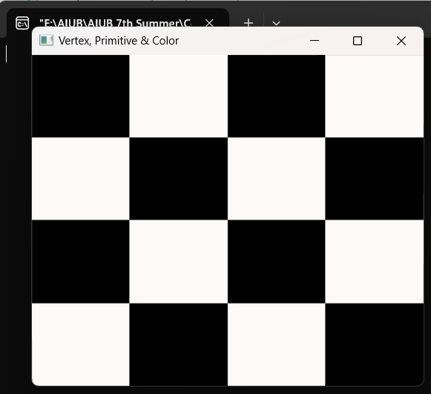
Output Screenshot (Full Screen)-

Question- 3

Create the batman logo given below-



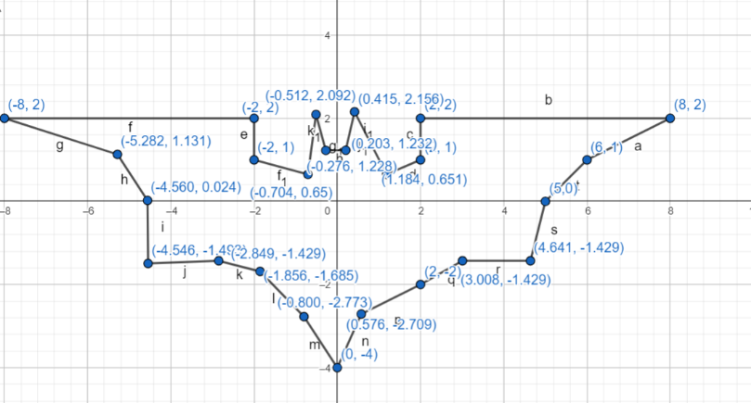
Graph Plot (Picture)-

Code-

#include <windows.h> // for MS Windows
#include <GL/glut.h> // GLUT, include glu.h and gl.h

/* Initialize OpenGL Graphics */
void initGL() {
// Set "clearing" or background color
glClearColor(0.0f, 0.0f, 0.0f, 1.0f); // Black and opaque
}

void display() {
glClear(GL_COLOR_BUFFER_BIT); // Clear the color buffer with current clearing color

glBegin(GL_POLYGON); // These vertices form a closed polygon
glColor3f(1.0f, 1.0f, 0.0f); // Yellow
glVertex2f(0.0f, -4.0f);
glVertex2f(0.576f,-2.709f);
glVertex2f(2.0f, -2.0f);
glVertex2f(3.008f, -1.429f);
glVertex2f(4.641f, -1.429f);
glVertex2f(5.0f, 0.0f);
glVertex2f(6.0f, 1.0f);
glVertex2f(8.0f, 2.0f);
glVertex2f(2.0f, 2.0f);
glVertex2f(2.0f, 1.0f);
glVertex2f(1.184f, 0.651f);
glVertex2f(0.415f, 2.156f);
glVertex2f(0.203f, 1.232f);
glVertex2f(-0.276f, 1.228f);
glVertex2f(-0.512f, 2.092f);
glVertex2f(-0.704f, 0.65f);
glVertex2f(-2.0f, 1.0f);
glVertex2f(-2.0f, 2.0f);
glVertex2f(-8.0f, 2.0f);
glVertex2f(-5.282f, 1.131f);
glVertex2f(-4.560f, 0.024f);
glVertex2f(-4.546f, -1.4930f);
glVertex2f(-2.8490f, -1.4290f);
glVertex2f(-1.8560f, -1.685f);
glVertex2f(-0.800f, -2.773f);

glEnd();

glFlush(); // Render now
}

/* Main function: GLUT runs as a console application starting at main() */
int main(int argc, char** argv) {
glutInit(&argc, argv); // Initialize GLUT
glutCreateWindow("Vertex, Primitive & Color"); // Create window with the given title
glutInitWindowSize(320, 320); // Set the window's initial width & height
glutInitWindowPosition(50, 50); // Position the window's initial top-left corner
glutDisplayFunc(display);
gluOrtho2D(-10,10,-10,10); // Register callback handler for window re-paint event
initGL(); // Our own OpenGL initialization
glutMainLoop(); // Enter the event-processing loop
return 0;
}


Output Screenshot (Full Screen)-

